Results for MAPbI$_3$ Control

Material Parameters
Effective mass of electron (me*): 0.138 mₑ
Effective mass of hole (mh*): 0.118 mₑ
Relative dielectric constant (εᵣ): 7.500

Peak Energy and FWHM vs Time
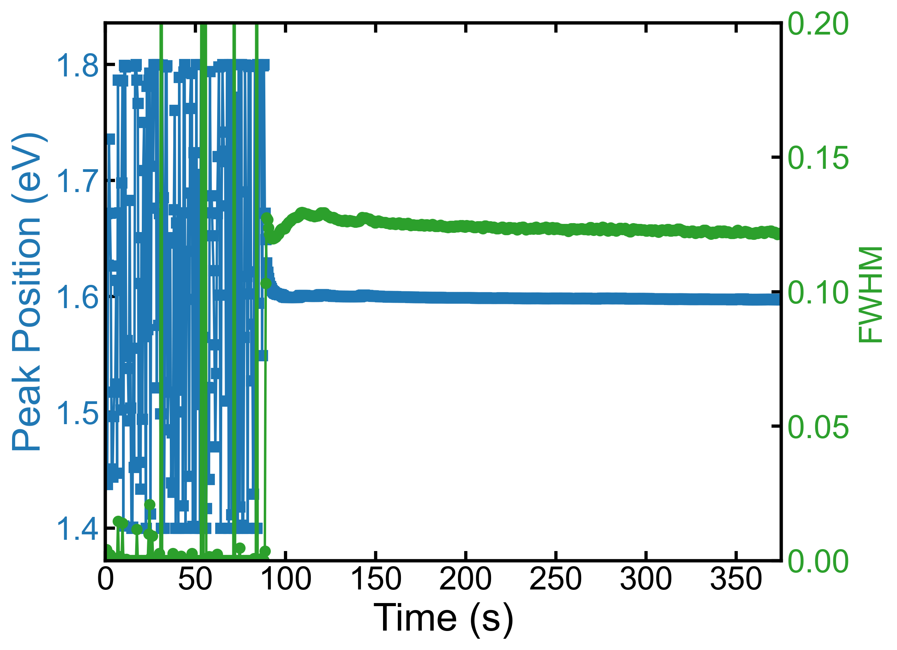

Peak Energy and Radius vs Time
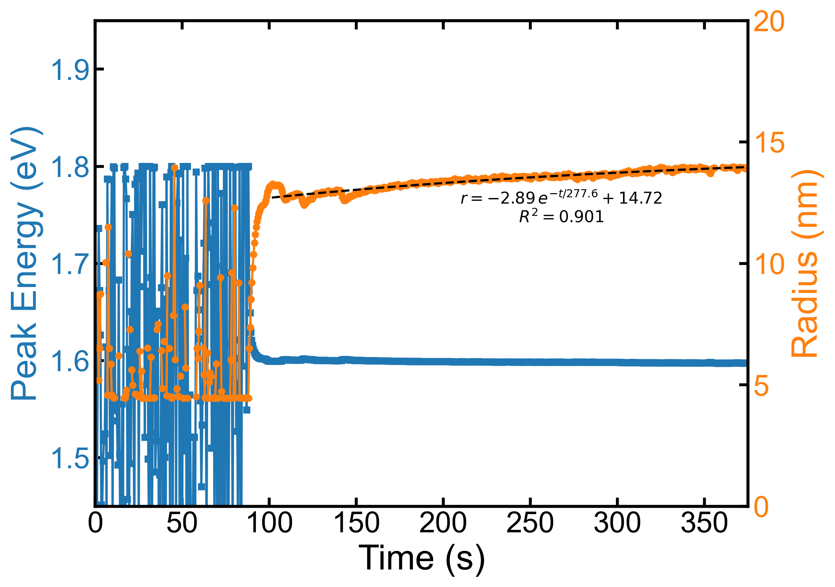

Region Bounds
Region 1: 38 to 83 s
Region 2: 83 to 101 s
Region 3: 101 to 374 s

Fitting Equations and R² Values
Region 1: r(t) = 1.00 * exp(-t / 50.0) + nan, R² = nan
Region 2: r(t) = 1.00 * exp(-t / 50.0) + nan, R² = nan
Region 3: r(t) = -2.89 * exp(-t / 277.6) + 14.72, R² = 0.901

Derivative Equations
Region 1: dr/dt = -0.020 * exp(-t / 50.0)
Region 2: dr/dt = -0.020 * exp(-t / 50.0)
Region 3: dr/dt = 0.010 * exp(-t / 277.6)

Growth Rates vs Time
